Creating a Mandatory profile

Taken from <http://www.carlstalhood.com/vmware-user-environment-manager/>

**Mandatory Profile**

If you want to use User Environment Manager with a Mandatory Profile then follow these instructions to create the mandatory profile: (See AppSense Bigot [Create Windows mandatory profiles in ten steps](http://appsensebigot.blogspot.ru/2014/10/create-windows-mandatory-profiles-in.html?m=1) and Microsoft’s [Create mandatory user profiles in Windows 10](https://technet.microsoft.com/en-us/itpro/windows/manage/mandatory-user-profile) for better instructions)

1. The mandatory profile is stored in a sub-folder of a file share. Either identify an existing file share (e.g. UEMConfig) or create a new file share.
2. Login to the Horizon 6 Agent machine as a template account. Do any desired customizations. Logoff.
3. Make sure you are viewing hidden files and system files.  
   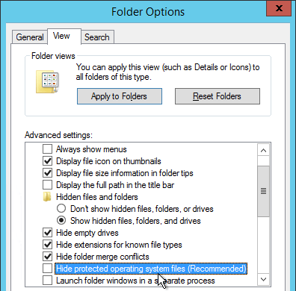
4. Copy **C:\Users\%username%** to your fileshare and rename the folder to mandatory.v2 or something similar. It is important that .v2 (or .v3 or .v4 or .v5 or .v6 depending on the operating system version) is on the end of the path. (e.g. **\\fs01\UEMConfig\mandatory.v6**).
   * Windows 7 and 2008 R2 = .v2
   * Windows 8.1 and 2012 R2 = .v2 or .v4, depending on if you configured <https://support.microsoft.com/en-us/kb/2887239> or not.
   * Windows 10 = .v5
   * Windows 10 1607 (Anniversary Update) = .v6
5. Note: the mandatory profile must be a subfolder of the file share. You cannot share the mandatory profile directly.  
   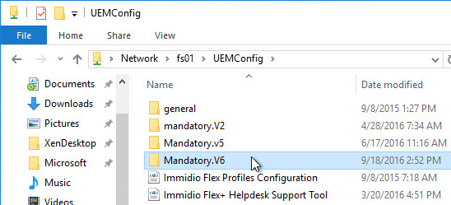
6. You can copy **C:\Users\Default** instead of copying a template user. If so, remove the hidden attribute. If you use Default as your mandatory, be aware that Active Setup will run every time a user logs in.  
   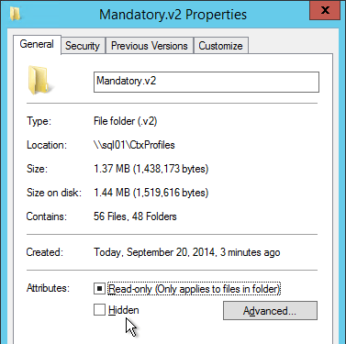
7. Rename **\\fs01\UEMConfig\mandatory.v6\ntuser.dat** to **ntuser.man**.
8. Delete the NTUSER.DAT log files.  
   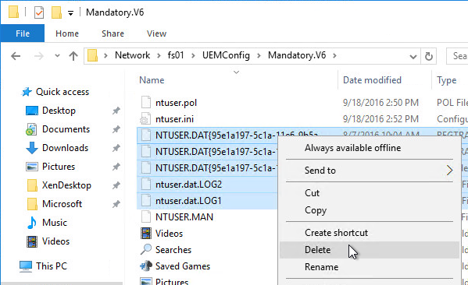
9. Open the **AppData** folder and delete the **Local** and **LocalLow** folders.  
   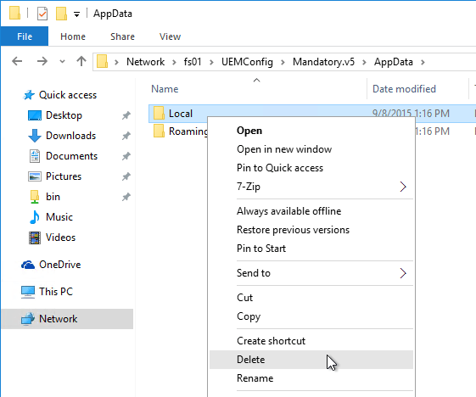
10. Java settings are stored in LocalLow so you might want to leave them in the mandatory profile. The only Java files you need are the **deployment.properties** file, the **exception.sites** file and the **security/trusted.certs** file. Delete the Java cache, tmp and logs.  
    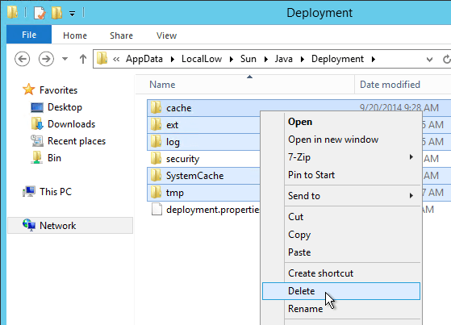
11. Open **regedit.exe**.
12. Click HKEY_LOCAL_MACHINE to highlight it.  
    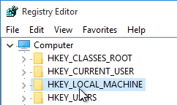
13. Open the **File** menu and click **Load Hive**.  
    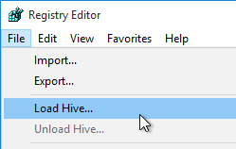
14. Browse to the mandatory profile and open NTUSER.MAN in the Mandatory profile folder.  
    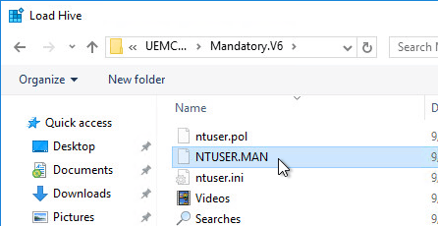
15. Name it **a** or similar.  
    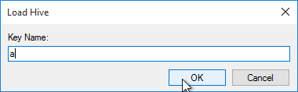
16. Go to **HKLM\a**, right-click it and click **Permissions**.  
    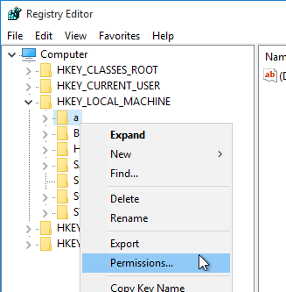
17. Add **Authenticated Users** and give it **Full Control**. Click **OK**.  
    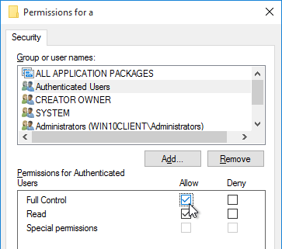
18. With the hive still loaded, you can do some cleanup in the registry keys. See <http://www.robinhobo.com/how-to-create-a-mandatory-profile-with-folder-redirections/> for some suggestions.
19. Also see [*How to create a Windows Server 2012 / Windows 8 Mandatory Profile*](http://www.jeroentielen.nl/howto-create-a-mandatory-profile-server-2012/) for more profile cleanup.
20. Highlight HKLM\a.  
    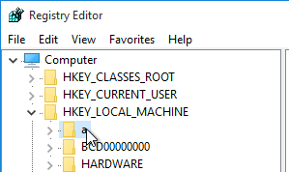
21. Open the **File** menu and click **Unload Hive**.  
    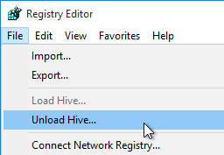
22. Create/Edit a GPO that applies to the Horizon 6 Agents and configure the following GPO settings:
    * Computer Configuration | Policies | Administrative Templates | System | User Profiles
      + **Do not check for user ownership of Roaming Profile Folders** = enabled
      + **Set roaming profile path for all users logging onto this computer** = **\\uem\UEMprofiles\mandatory** (Do not include the .v6 in this path)
    * Computer Configuration | Policies | Administrative Templates | Windows Components | Remote Desktop Services | Remote Desktop Session Host | Profiles
      + **Use mandatory profiles on the RD Session Host server** = enabled
      + **Set path for Remote Desktop Services Roaming User Profile** = **\\uem\UEMprofiles\mandatory** (Do not include the .v6 in this path)